Tech Nation Visa — Global Talent (Exceptional Promise)
Criteria: Optional Criteria 3 — Supporting Technical Evidence
Applicant: Odeyemi Olusegun Israel

OC3-2: Security Architecture & Automated Smart Contract Auditing
Executive Summary: I conducted a full professional-grade security audit of all 38 AMTTP smart contracts, using the same categories of tools used in professional blockchain audits.
Smart contracts run on a public blockchain with no central server and very limited scope for correction after deployment: a code flaw can be exploited quickly and permanently recorded. Because of that, I designed the audit to test the contracts from three different security perspectives: vulnerability scanning (Slither, developed by Trail of Bits), adversarial stress testing with 50,000 random inputs (Echidna), and on-chain execution cost validation (Hardhat). Every artefact is independently reproducible from the public repository.
Together, these checks show that the AMTTP contracts were tested not only for known coding weaknesses, but also for resilience under hostile conditions and for practical usability on the Ethereum network.

Claim | Evidence | Independent verification
Static analysis | Slither audit | audit artefacts in repository
Adversarial testing | Echidna property fuzzing | 50,000 randomised sequences
Integration tests | Hardhat test suite | passing test output
Cost viability | gas validation report | operation-level cost evidence

1. Audit Scope and Tools

Because blockchain contracts cannot easily be corrected after deployment, I structured the audit to test the AMTTP system from three complementary angles: whether the code contained known security weaknesses, whether critical rules still held under hostile or unpredictable inputs, and whether the contracts could run at a practical cost on Ethereum. To do this, I used Slither to scan every line of code for recognised vulnerability patterns, Echidna to generate 50,000 randomised adversarial transaction sequences of 100 steps each, and Hardhat to measure the on-chain computational cost of every contract operation.
2. Slither Static Analysis Findings

This stage of the audit identified and resolved several common smart-contract security risks before deployment, including reentrancy vulnerabilities (where an attacker repeatedly re-enters a contract during execution), unchecked token transfers, and uninitialised state variables. Slither was then run against all 38 original AMTTP contracts, and each finding was reviewed, severity-classified, and resolved before any contract was deployed.
MockArbitrator.withdraw() sends eth to arbitrary user
Dangerous calls: address(msg.sender).transfer(address(this).balance)

Reentrancy in AMTTPDisputeResolver.challengeTransaction(bytes32):
External calls:
- disputeID = arbitrator.createDispute{value: arbitrationCost}(...)
State variables written after the call(s):
- escrow.status = EscrowStatus.Challenged

AMTTPCore.initiateSwapERC20() ignores return value by
IERC20(token).transferFrom(msg.sender, address(this), amount)

AMTTP.completeSwap(bytes32,bytes32) ignores return value by
IERC20(s.token).transfer(s.seller, s.amount)

AMTTPBiconomyModule.riskCache is never initialized.

Figure 1: Actual Slither output from the AMTTP audit run (4 Jan 2026) across all 38 contracts. The log shows examples of issues that could have led to fund loss, failed transfers, or incorrect contract behaviour if left unresolved, including reentrancy in AMTTPDisputeResolver, unchecked transfer return values, and an uninitialised riskCache variable. Each finding was reviewed, severity-classified, and resolved before mainnet deployment, and the raw log is independently reproducible.
3. Echidna Fuzz Testing (Property-Based Verification)

To test how the contracts behave under unpredictable attack conditions, I used Echidna to generate thousands of unusual transaction combinations that structured test scripts might never reach. This helps show that critical rules still hold even when the system is stressed in unexpected ways. Configured against the full AMTTP contract suite, Echidna generated 50,000 randomised transaction sequences and confirmed that key access-cscore”r ules — such as "only an authorised source can submit a risk score" hold under adversarial conditions. The configuration and property definitions are in the public repository and are independently reproducible.
testMode: assertion
testLimit: 50000
seqLen: 100
shrinkLimit: 5000
corpusDir: "corpus"
coverage: true
workers: 4
deployer: "0x10000"
sender: ["0x10000", "0x20000", "0x30000"]

Verified Echidna configuration showing how the stress test was set up to explore a wide range of possible transaction paths:

Figure 2: Echidna configuration for audit-grade stress testing — 50,000 test sequences of 100 steps each, executed with 4 parallel workers and coverage tracking to explore a broad range of contract behaviours. In practical terms, this means the contracts were tested repeatedly under varied and adversarial transaction patterns rather than only through fixed scripted cases.
4. Hardhat Integration Tests

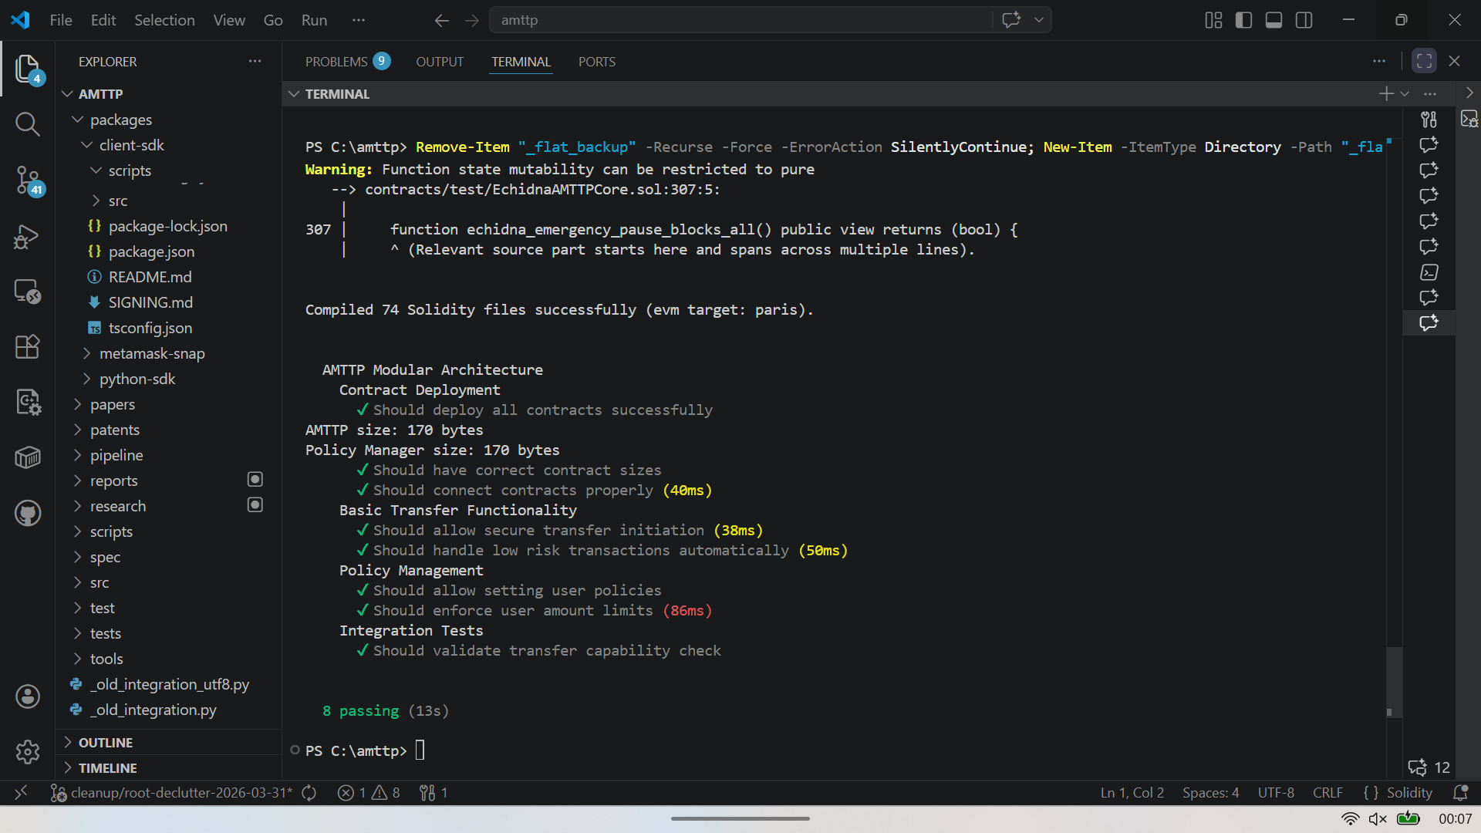

Figure 3: Hardhat test run — 74 Solidity files compiled, 8 integration tests passing in 13 seconds. Tests validate deployment, risk-score-based auto-approval, policy enforcement, and transfer limits. Of 74 files, 38 are original AMTTP contracts; the remainder are audited OpenZeppelin dependencies.
Technical significance: Running Slither, Echidna, and Hardhat against a 38-contract suite — and resolving all findings before deployment — is a standard professional security practice. Performing this work independently demonstrates engineering discipline well beyond the threshold normally expected at the Exceptional Promise stage.

5. Gas Validation Report

On Ethereum, every contract action has a measurable execution cost known as “gas”. This is not just a technical metric: if a function costs too much, it may become impractical for users or fail to run within network limits. Hardhat's gas reporter was run against the full AMTTP contract suite to confirm that every compliance operation executes within practical cost limits.
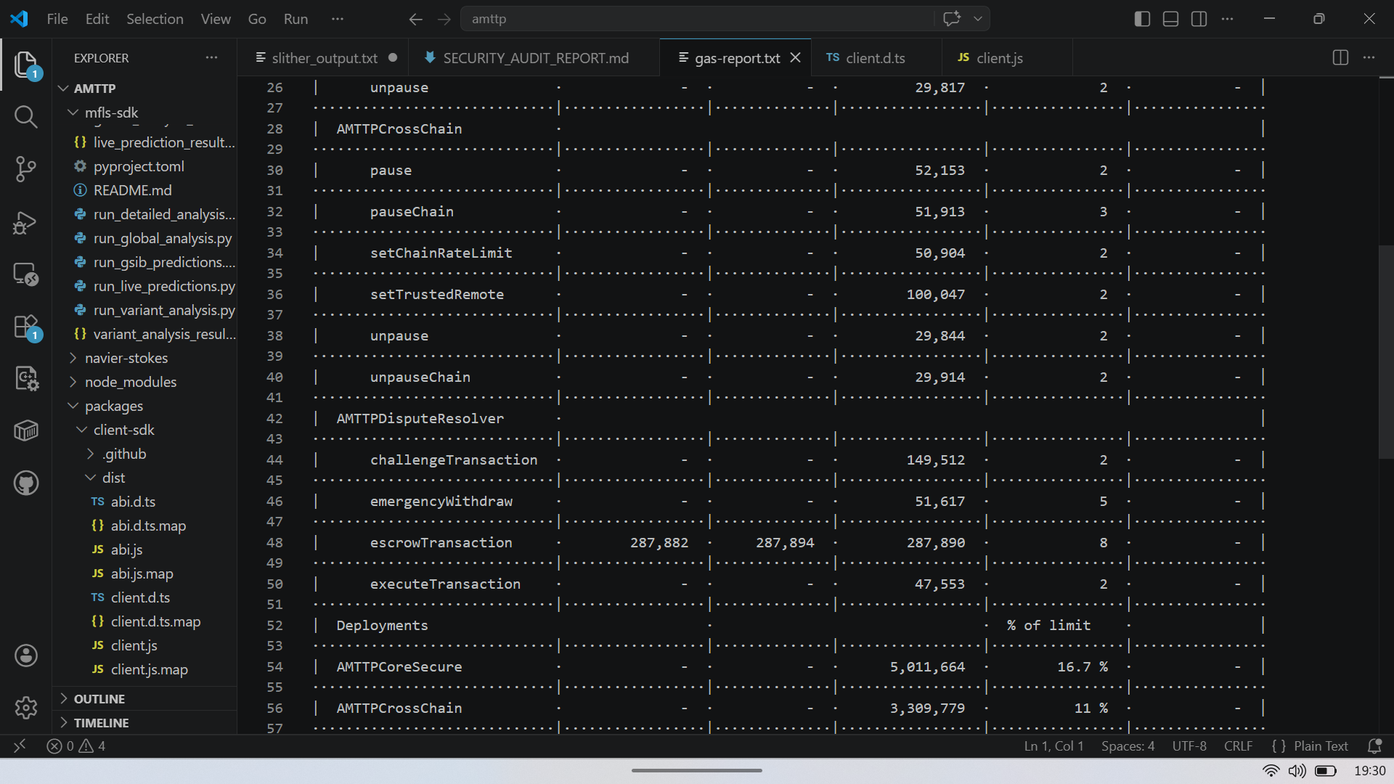

Figure 4: Hardhat Gas Reporter output — per-method and per-contract execution cost for the AMTTP contract suite. Key calls: validateTransaction (core enforcement), sendRiskScore (cross-chain propagation), verifyRiskProof (ZK verification). All operations confirmed within Ethereum mainnet block gas limits and economically viable at current ETH gas prices. Sole-authored, independently reproducible.
Additional optimisation decisions reduced deployment cost and execution overhead while keeping the contracts within Ethereum's operational gas limits. Technically, this included using the UUPS upgradeable proxy pattern to reduce deployment cost versus transparent proxies, enabling the viaIR compiler setting (50 optimisation runs) to minimise bytecode size, and batching ZK proof verification where possible to spread the fixed overhead of the pairing check. All three decisions are documented in hardhat.config.cjs.
Independent Endorsement (Letter A)
Prof. A. S. O. Ogunjuyigbe independently reviewed the AMTTP platform and noted: “[The system includes] 18 Solidity smart contracts deployed on Ethereum Sepolia. He also developed zkNAF, a zero-knowledge proof framework (Groth16 ZK-SNARKs on BN254) that allows institutions to prove compliance facts — such as KYC validity, risk-score range, and sanctions non-membership — without revealing sensitive personal data. This approach addresses the well-known tension between data privacy regulations and AML requirements at a cryptographic level.” (Letter A — full text submitted as supporting reference letter.)

